AWS VPC, EC2, ALB, S3, CloudWatch & Auto Scaling Lab
N. Virginia (us-east-1) — Console Step-by-Step Procedure

Objective
Build a two-subnet AWS network in the N. Virginia region, deploy Apache on public and private EC2 instances, place both behind an Application Load Balancer, store ALB access logs in Amazon S3, send VPC Flow Logs to Amazon CloudWatch Logs, create monitoring dashboards, and configure CPU-based Auto Scaling when average CPU utilization exceeds 70%.

Architecture Overview
Internet
|
Internet Gateway
|
+--------------------------- VPC 10.0.0.0/16 ---------------------------+
| Public Subnet 10.0.1.0/24 | Private Subnet 10.0.2.0/24 |
| Application Load Balancer | Apache EC2 / Auto Scaling |
| NAT Gateway | |
| Public EC2 (Apache) | |
+-----------------------------------------------------------------------+
ALB Access Logs -> S3
VPC Flow Logs -> CloudWatch Logs
EC2 CPU / Apache Monitoring -> CloudWatch Dashboard
CPU > 70% -> CloudWatch Alarm -> Auto Scaling -> New EC2

Important Architecture Note
A NAT Gateway is not directly attached to a private subnet. The private subnet is associated with a private route table whose default route (0.0.0.0/0) points to the NAT Gateway. The NAT Gateway itself must be deployed in a public subnet and use a public route through the Internet Gateway.
For Auto Scaling, the scalable EC2 instances should be created by a Launch Template and Auto Scaling Group. The manually created public EC2 can remain as a demonstration instance, while the private application tier is managed by the Auto Scaling Group. For production/high availability, use at least two Availability Zones and two private subnets.

Prerequisites
- AWS account with permission to create VPC, EC2, IAM, ALB, S3, CloudWatch, NAT Gateway and Auto Scaling resources.
- An EC2 key pair available in us-east-1.
- A personal public IP address for restricting SSH access to the public EC2.
- Select US East (N. Virginia) / us-east-1 before starting.

1. Select N. Virginia Region
AWS Console → Region selector → US East (N. Virginia) — us-east-1.

2. Create the VPC
VPC Console → Your VPCs → Create VPC → VPC only.
- Name tag: DevOps-VPC
- IPv4 CIDR: 10.0.0.0/16
- IPv6: No IPv6 CIDR block
- Tenancy: Default
Click Create VPC. 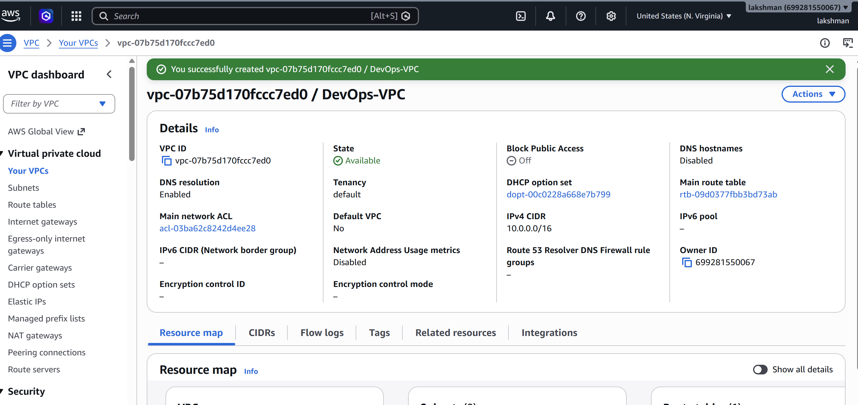

3. Create the Public Subnet
VPC → Subnets → Create subnet.
- VPC: DevOps-VPC
- Subnet name: Public-Subnet
- Availability Zone: us-east-1a
- IPv4 CIDR: 10.0.1.0/24
Create the subnet. Enable auto-assign public IPv4 at subnet level if desired, or enable it for the public EC2 during launch. 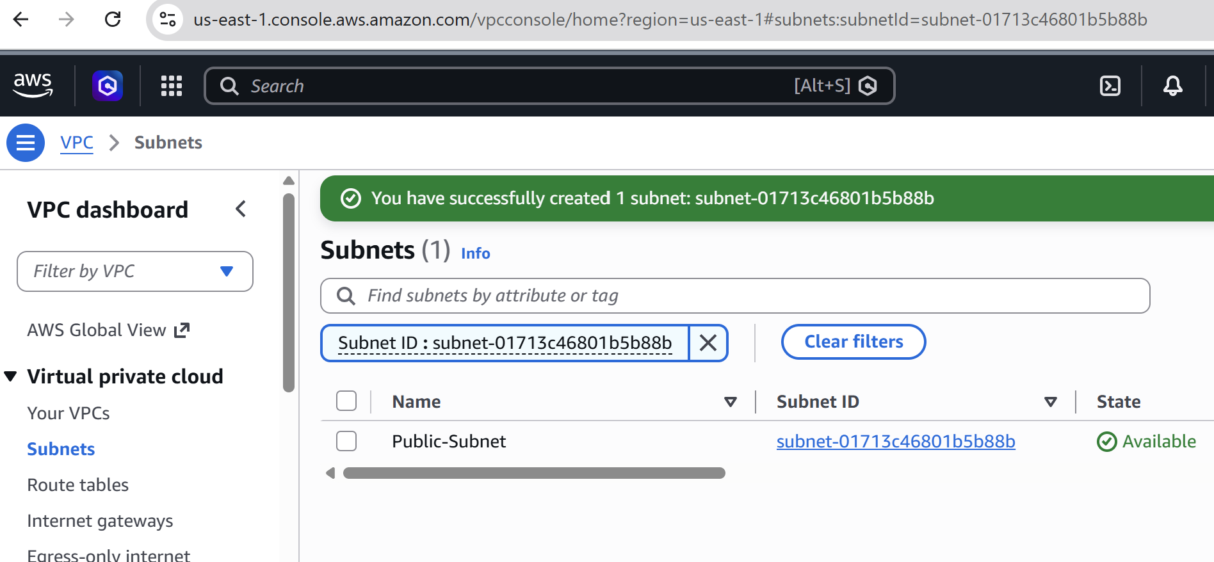

4. Create the Private Subnet
VPC → Subnets → Create subnet.
- VPC: DevOps-VPC
- Subnet name: Private-Subnet
- Availability Zone: us-east-1a
- IPv4 CIDR: 10.0.2.0/24
Keep public IPv4 assignment disabled for the private subnet. 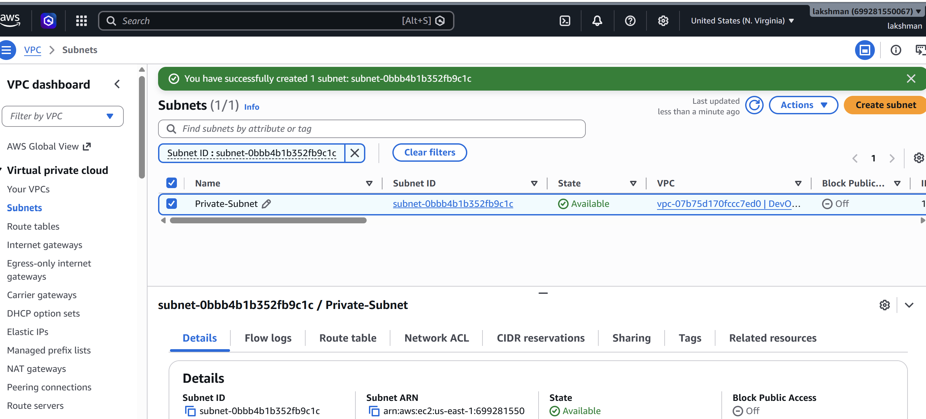

5. Create and Attach an Internet Gateway
VPC → Internet Gateways → Create internet gateway.
Name: DevOps-IGW. After creation, select Actions → Attach to a VPC → DevOps-VPC → Attach. 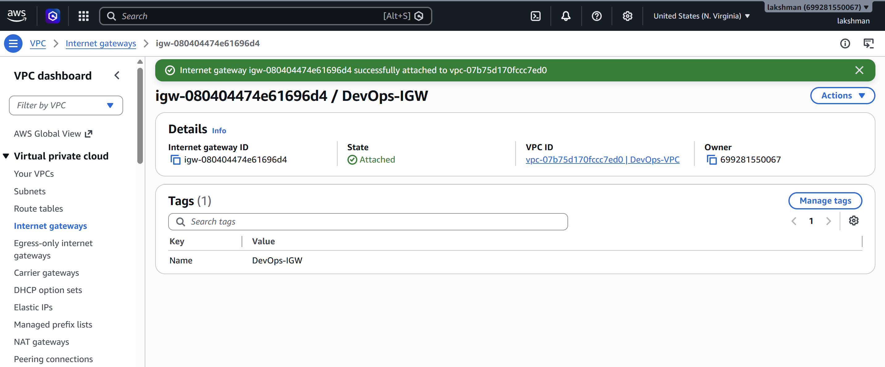

6. Create the Public Route Table
VPC → Route Tables → Create route table.
- Name: Public-RT
- VPC: DevOps-VPC
Routes → Edit routes → Add route: Destination 0.0.0.0/0 → Target Internet Gateway → DevOps-IGW.
Subnet associations → Edit subnet associations → select Public-Subnet → Save. 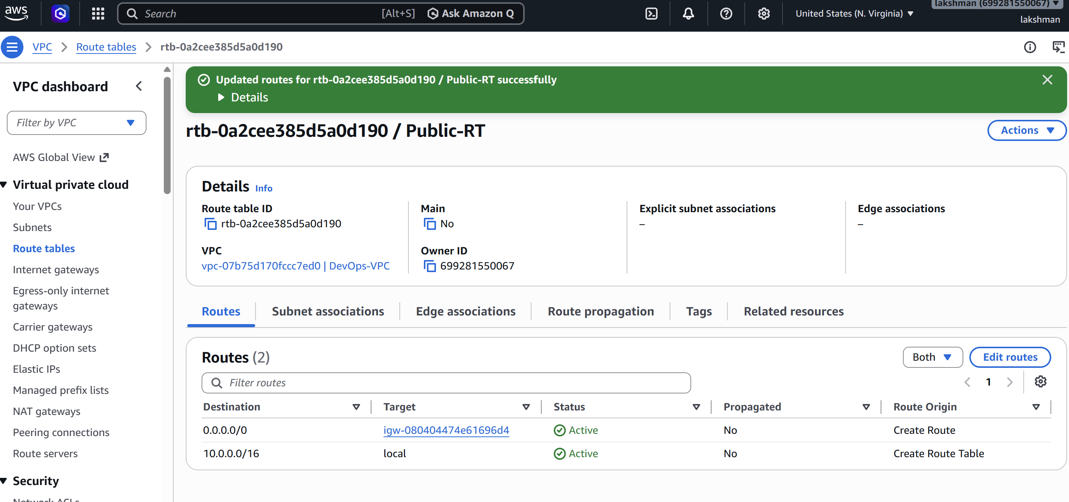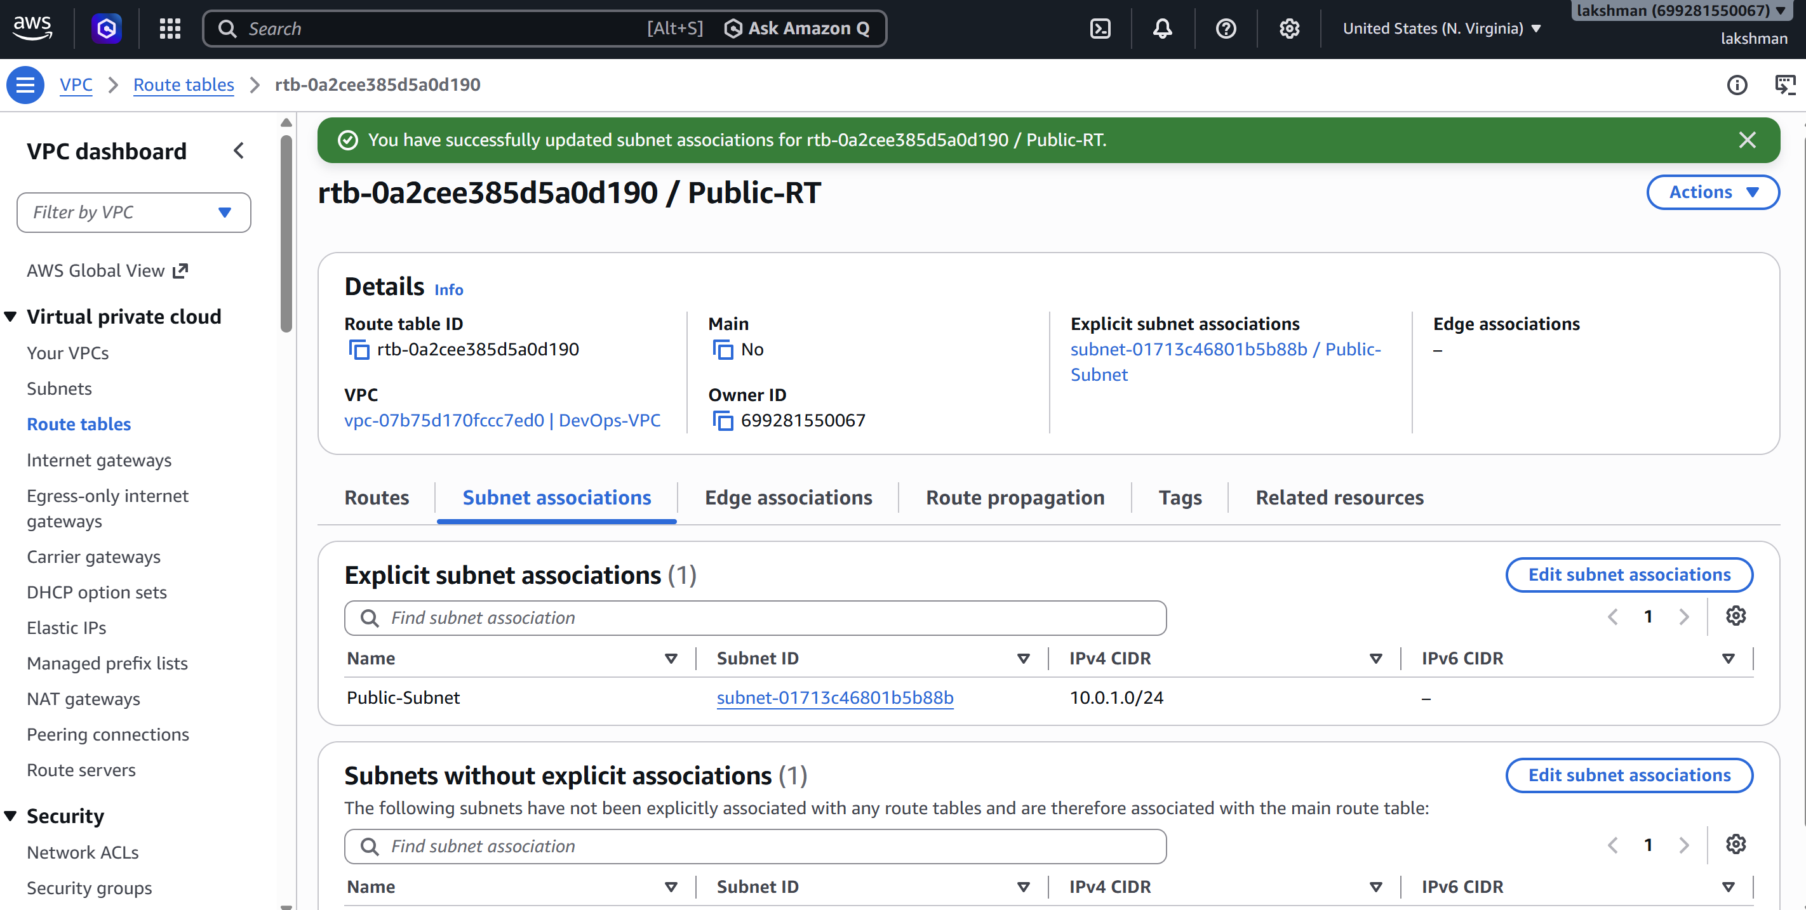

7. Create the Private Route Table
VPC → Route Tables → Create route table.
Name: Private-RT; VPC: DevOps-VPC. Associate Private-Subnet with this route table.
Do not add the NAT route until the NAT Gateway is created. 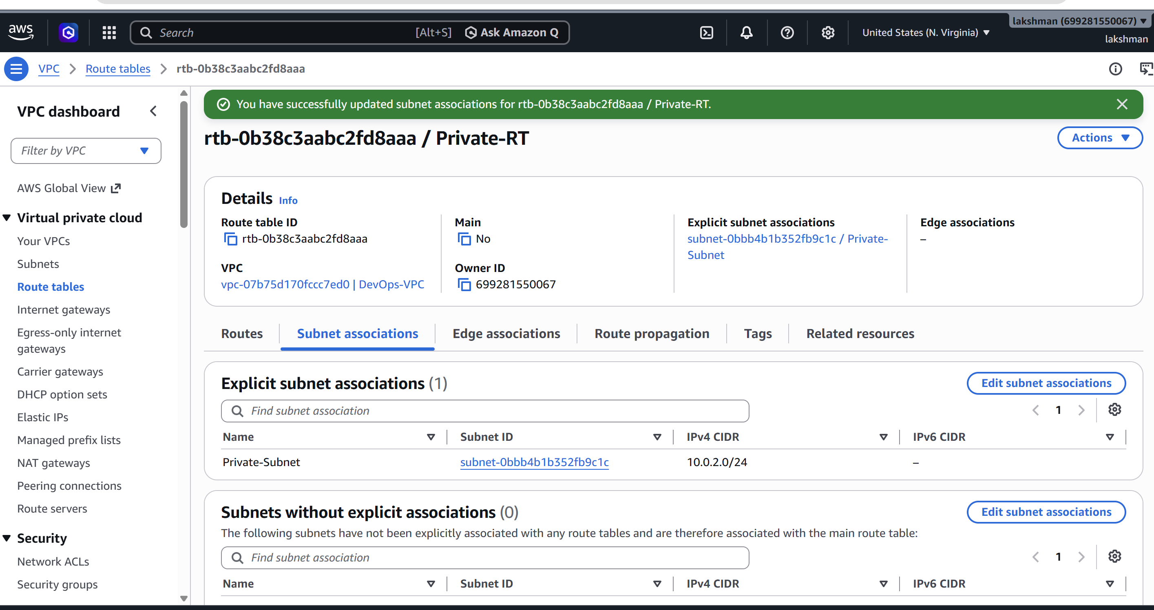

8. Create the NAT Gateway
VPC → NAT Gateways → Create NAT gateway.
- Name: DevOps-NAT
- Subnet: Public-Subnet
- Connectivity type: Public
- Elastic IP: Allocate Elastic IP
Create the NAT Gateway and wait until its status becomes Available. 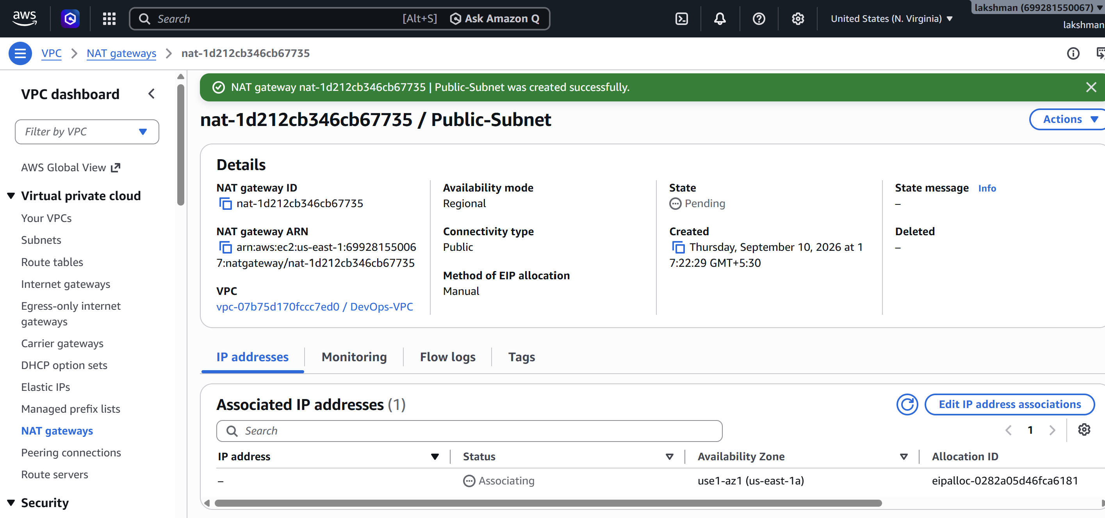

9. Add the NAT Route to the Private Route Table
VPC → Route Tables → Private-RT → Routes → Edit routes → Add route.
Destination: 0.0.0.0/0 → Target: NAT Gateway → select DevOps-NAT → Save changes.
Result: Private EC2 → Private-RT → NAT Gateway → Public-RT/IGW → Internet. 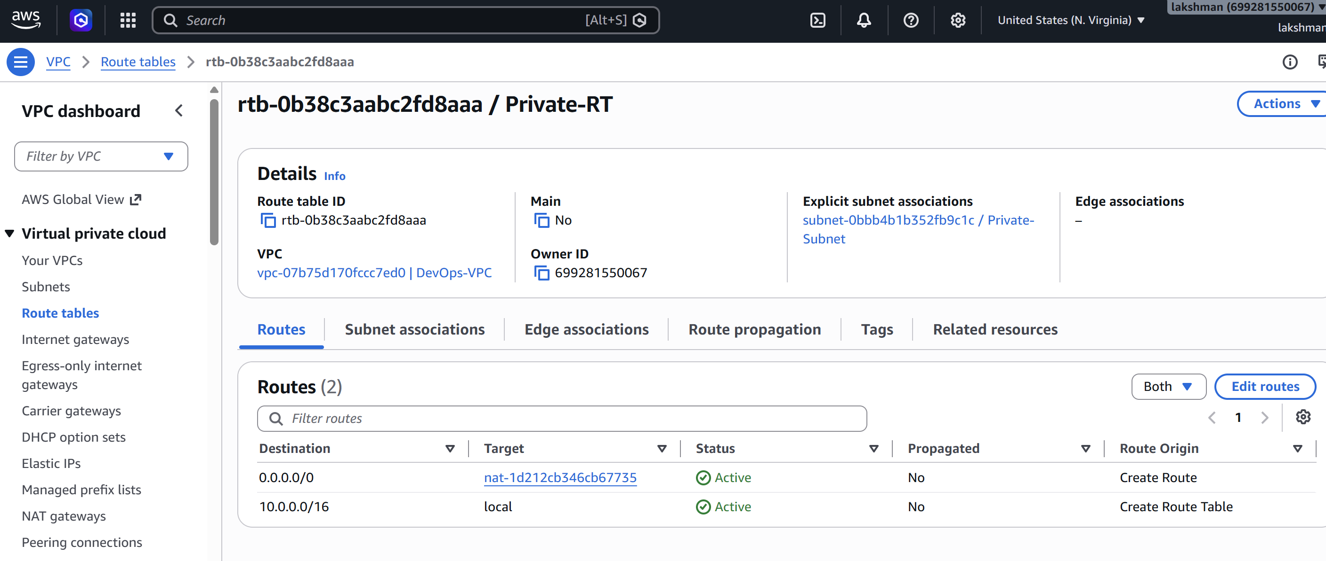

10. Create Security Groups
Create ALB-SG:
- Inbound HTTP TCP 80 from 0.0.0.0/0
- Inbound HTTPS TCP 443 from 0.0.0.0/0 (optional)
Create EC2-SG:
- Inbound SSH TCP 22 from My IP only
- Inbound HTTP TCP 80 from the ALB-SG security group
Using the ALB-SG as the source for EC2 port 80 is preferred over opening Apache to the entire internet. 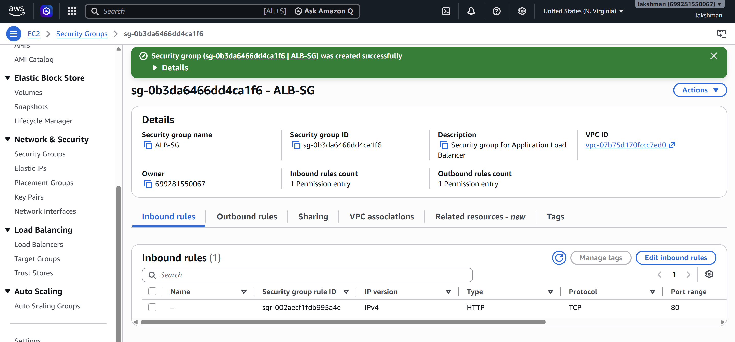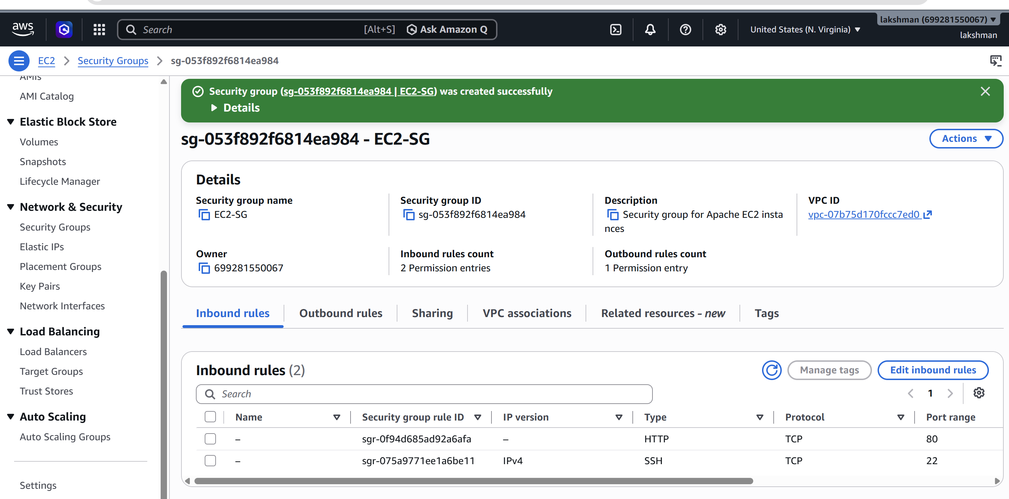

11. Launch the Public EC2 Instance
EC2 → Instances → Launch instance.
- Name: Apache-Public
- AMI: Amazon Linux 2023
- Instance type: t3.micro (lab example)
- VPC: DevOps-VPC
- Subnet: Public-Subnet
- Auto-assign public IP: Enable
- Security group: EC2-SG
- Select your EC2 key pair
Launch the instance. 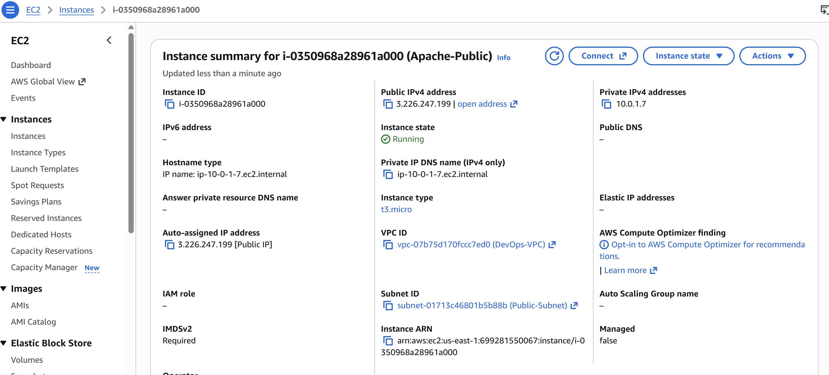

12. Launch the Private EC2 Instance
Launch another Amazon Linux 2023 instance.
- Name: Apache-Private
- Instance type: t3.micro
- VPC: DevOps-VPC
- Subnet: Private-Subnet
- Auto-assign public IP: Disable
- Security group: EC2-SG
- Select the same key pair if appropriate
Launch the instance. The private instance does not need a public IP. 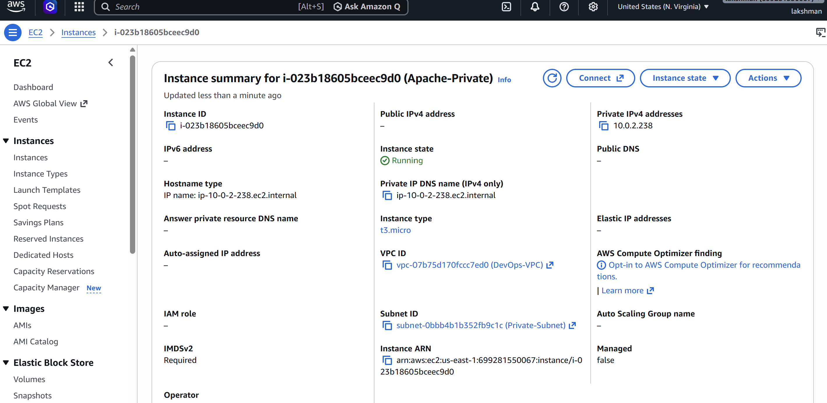

13. Install Apache on the Public EC2
Connect using SSH:
ssh -i your-key.pem ec2-user@PUBLIC-IP
sudo dnf update -y
sudo dnf install httpd -y
sudo systemctl enable --now httpd
sudo systemctl status httpd
Create /var/www/html/index.html with:
<!DOCTYPE html>
<html>
<head><title>Public Apache Server</title></head>
<body>
<h1>Hello from Public EC2</h1>
<p>Apache Web Server - Public Subnet</p>
</body>
</html>
Test with: curl http://localhost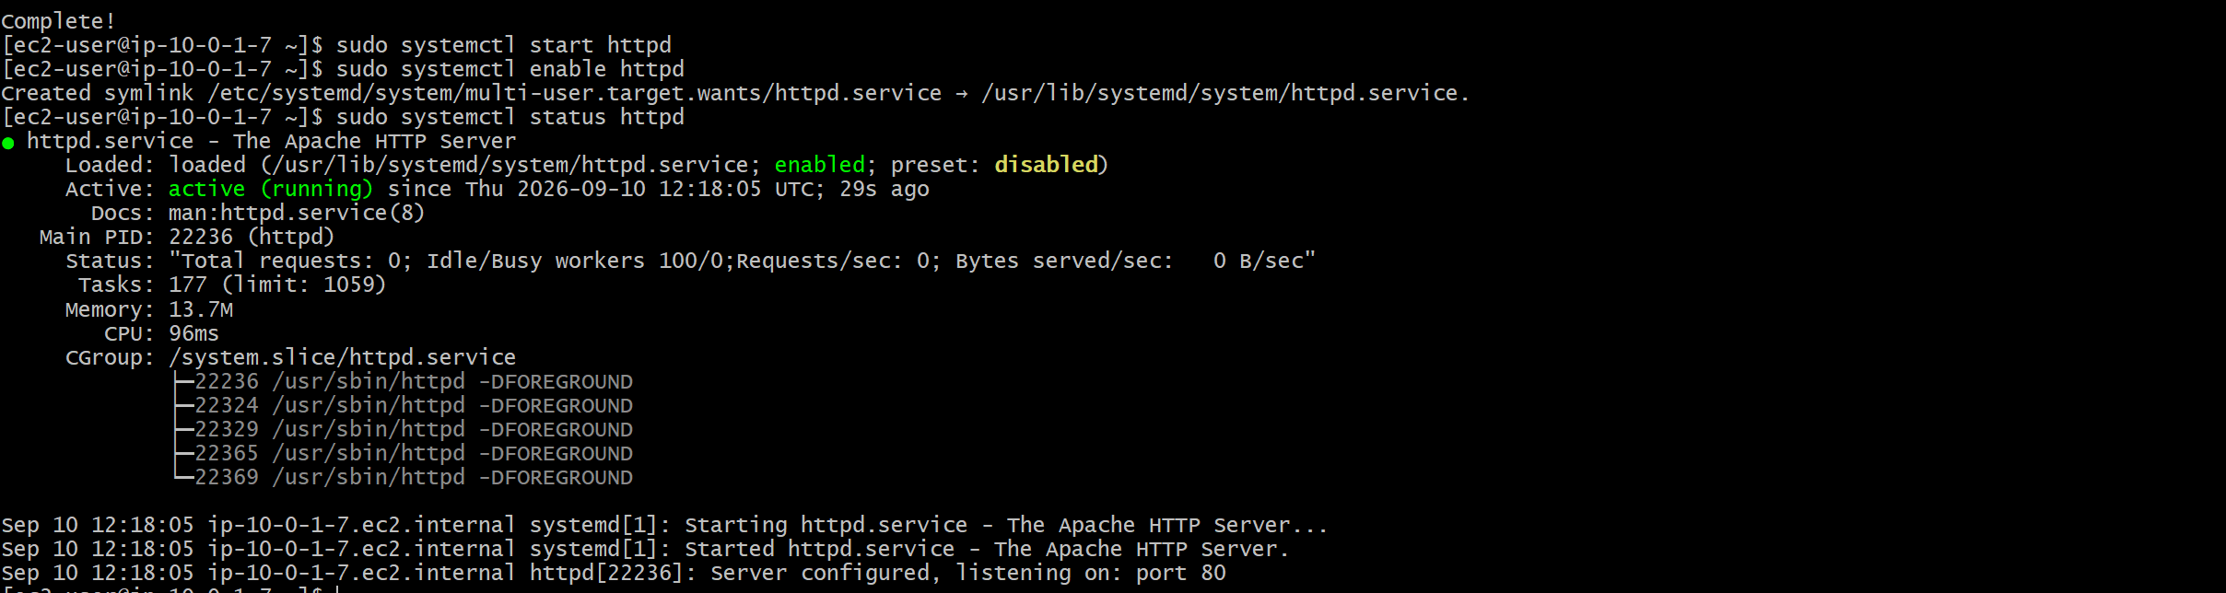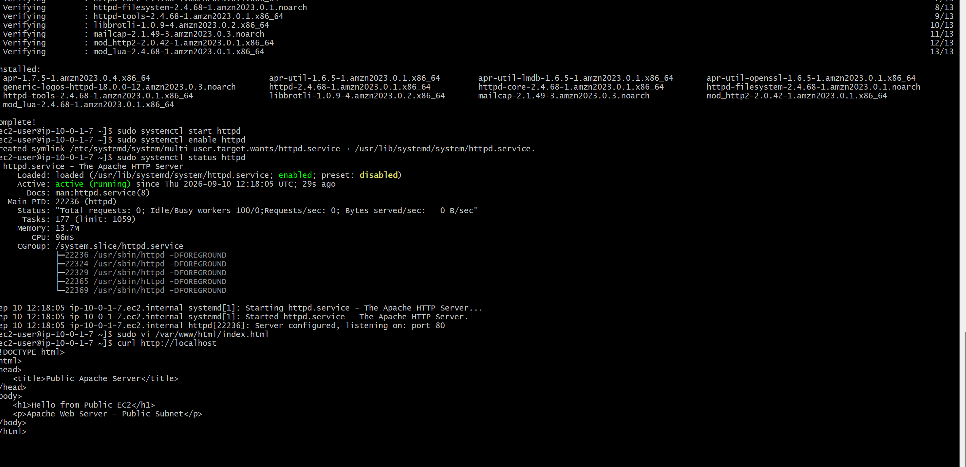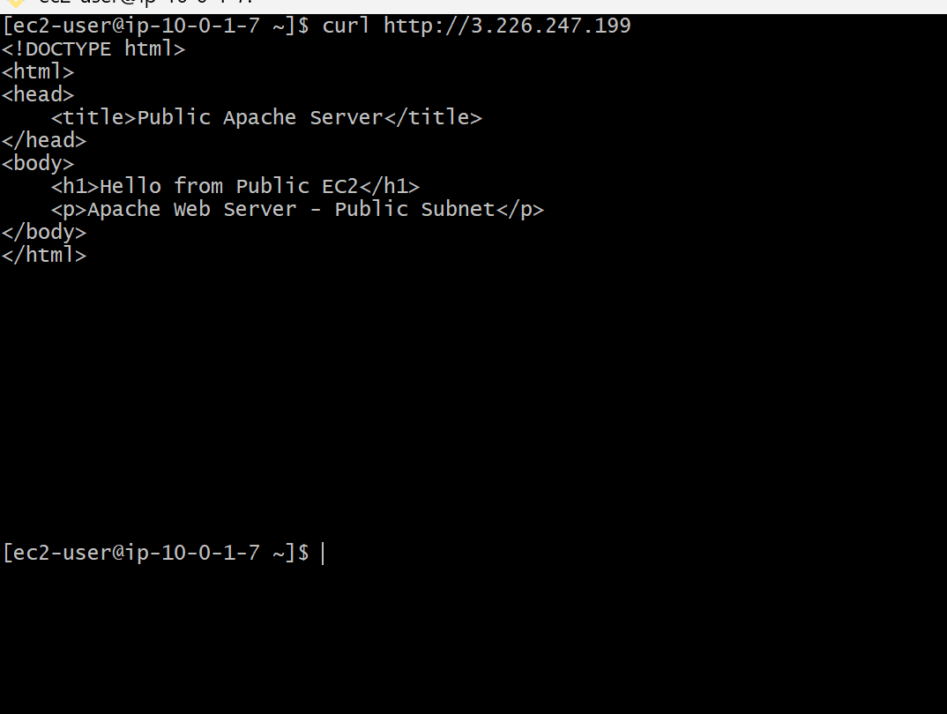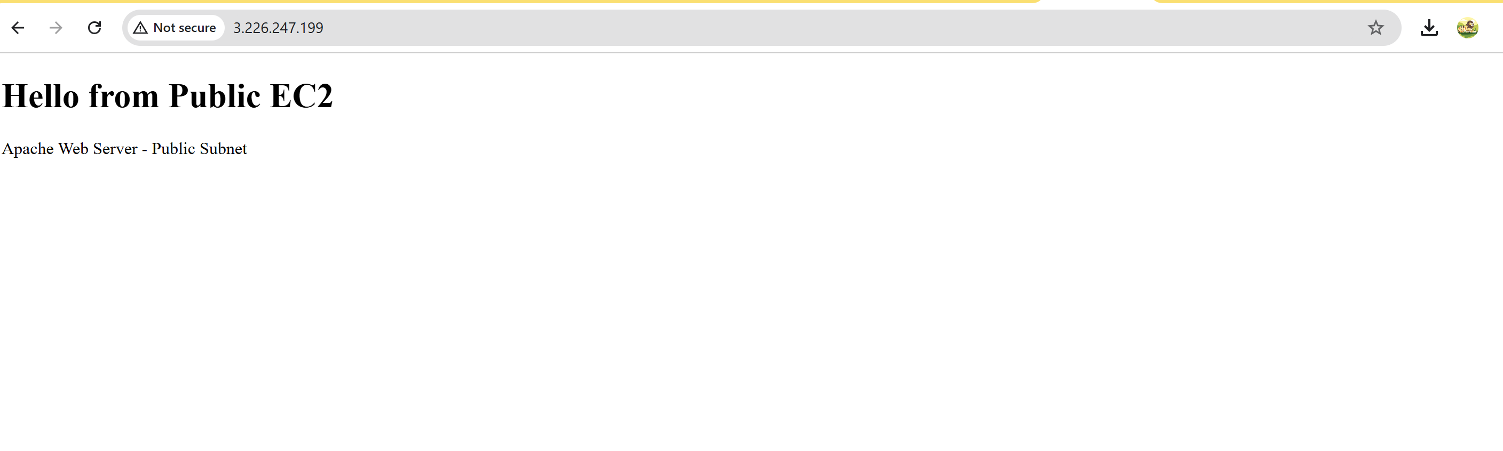

14. Install Apache on the Private EC2
Connect to the private EC2 through a bastion/SSH forwarding method or another approved management method. Do not expose SSH publicly just to manage the private instance.
sudo dnf update -y
sudo dnf install httpd -y
sudo systemctl enable --now httpd
sudo systemctl status httpd
Create /var/www/html/index.html:
<!DOCTYPE html>
<html>
<head><title>Private Apache Server</title></head>
<body>
<h1>Hello from Private EC2</h1>
<p>Apache Web Server - Private Subnet</p>
</body>
</html>
Test with: curl http://localhost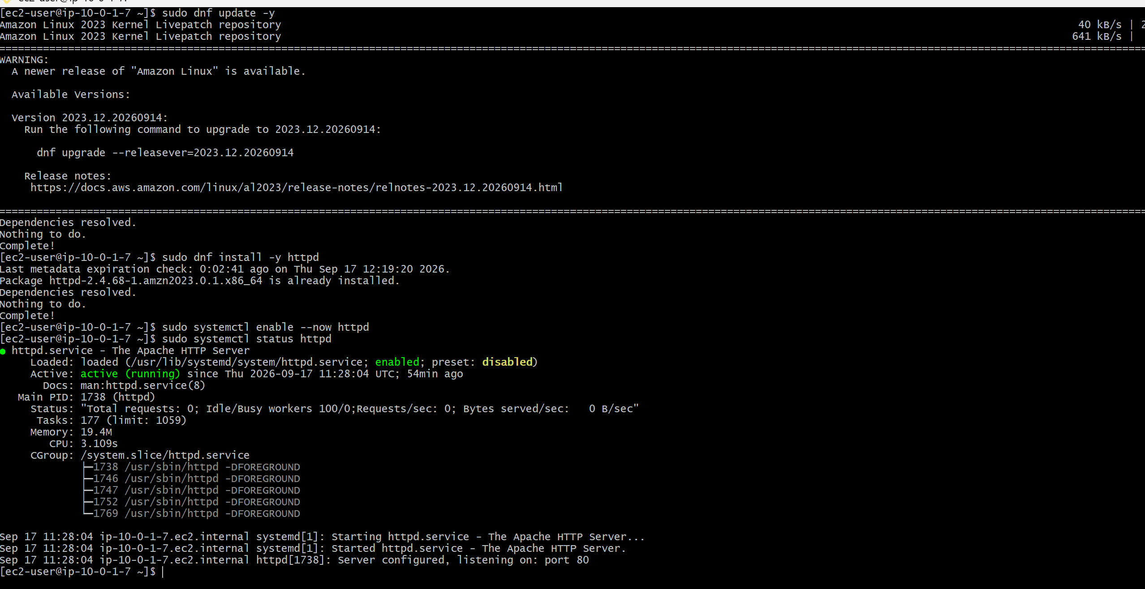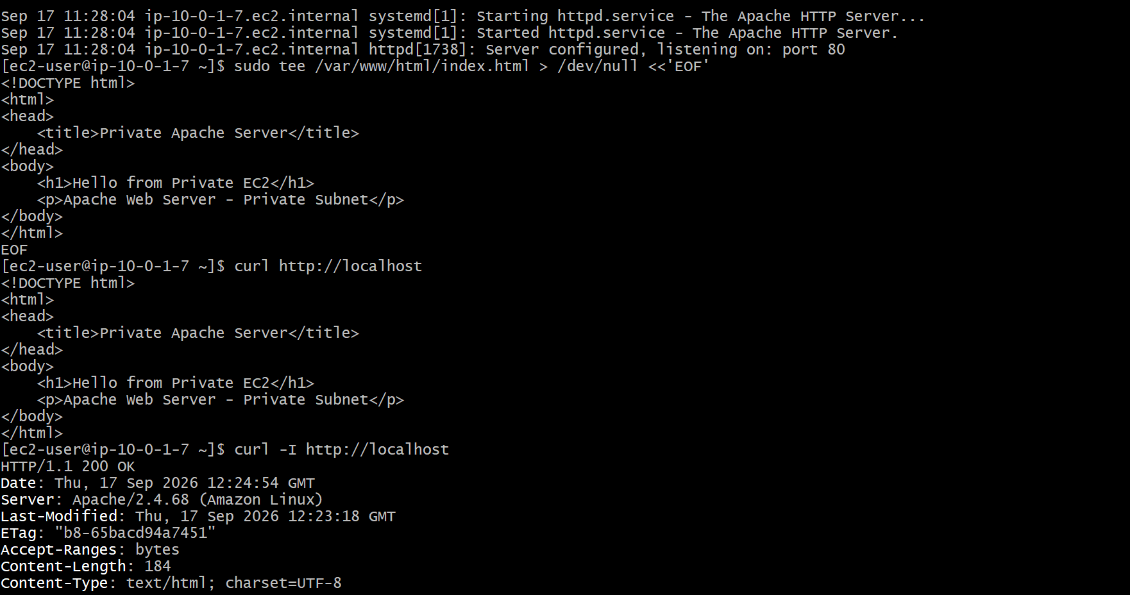

15. Create the ALB Target Group
EC2 → Target Groups → Create target group.
- Target type: Instances
- Name: Apache-TG
- Protocol: HTTP
- Port: 80
- VPC: DevOps-VPC
- Health check protocol: HTTP
- Health check path: /
Register Apache-Public and Apache-Private as targets. Wait for both targets to become Healthy. 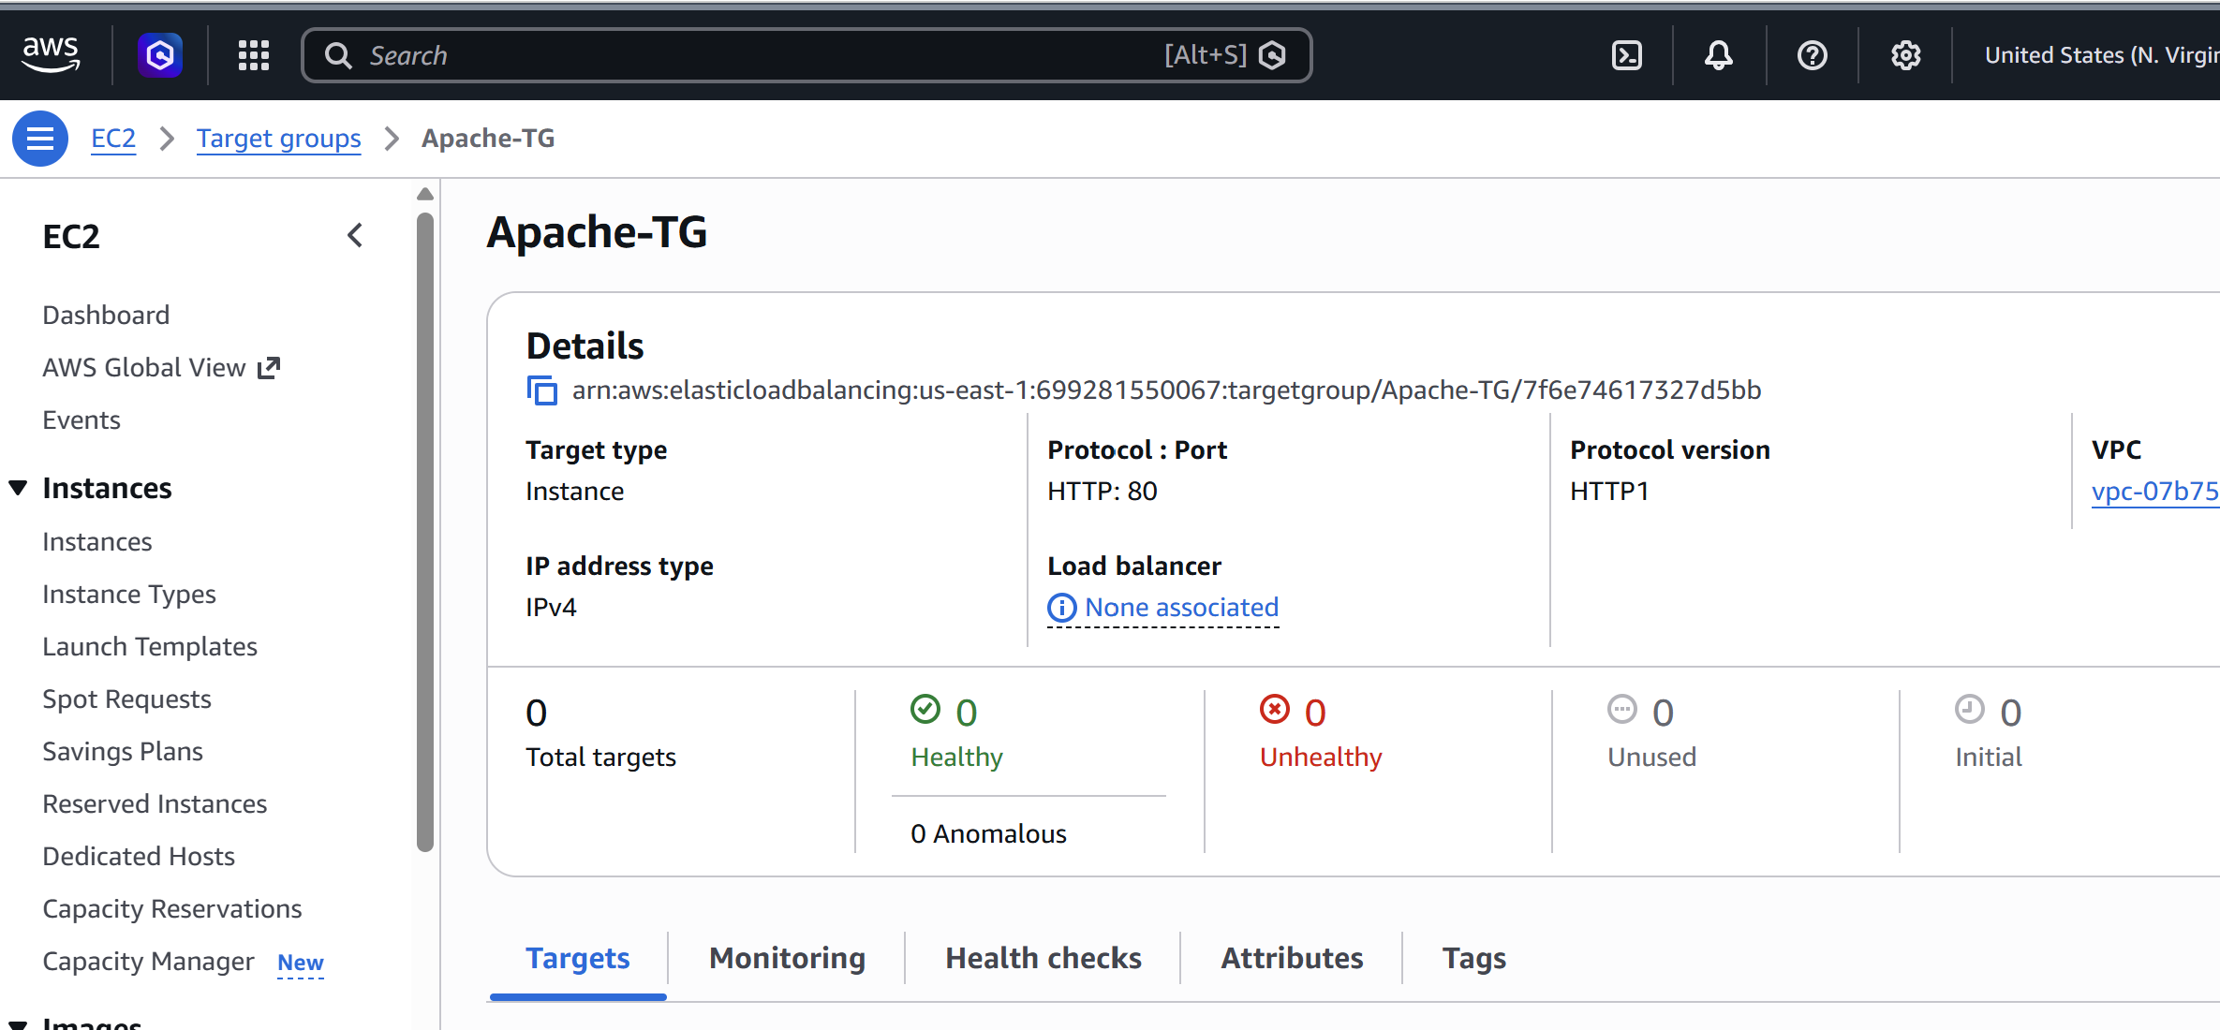

16. Create the Application Load Balancer
EC2 → Load Balancers → Create Load Balancer → Application Load Balancer.
- Name: DevOps-ALB
- Scheme: Internet-facing
- IP address type: IPv4
- VPC: DevOps-VPC
- Select public subnets in at least two AZs when available
- Security group: ALB-SG
- Listener: HTTP :80 → Forward to Apache-TG
Create the load balancer.
Open the ALB DNS name in a browser. The request should reach one of the healthy Apache targets. 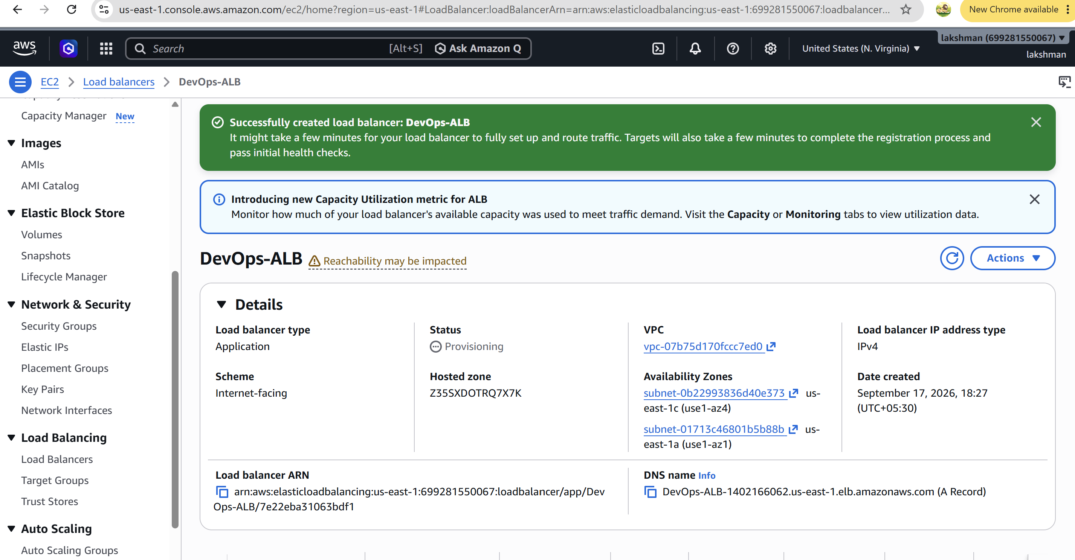

17. Create an S3 Bucket for ALB Access Logs
S3 → Create bucket.
- Choose a globally unique bucket name, e.g. devops-alb-logs-2026-yourname
- Region: us-east-1
- Block all public access: Enabled
- Object Ownership: Bucket owner enforced
Create the bucket. Keep it private. 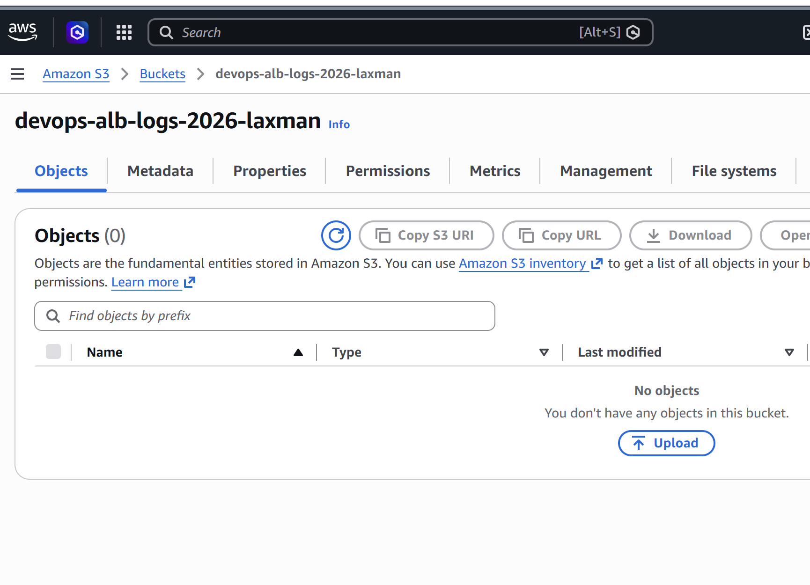

18. Enable ALB Access Logs to S3
EC2 → Load Balancers → DevOps-ALB → Attributes → Access logs → Enable.
Choose S3 as the destination and enter the ALB log bucket. Save changes.
If AWS requests a bucket policy, apply the policy/permissions displayed by the current AWS console for the ALB logging service. Generate ALB traffic and verify that AWSLogs/objects appear in S3. 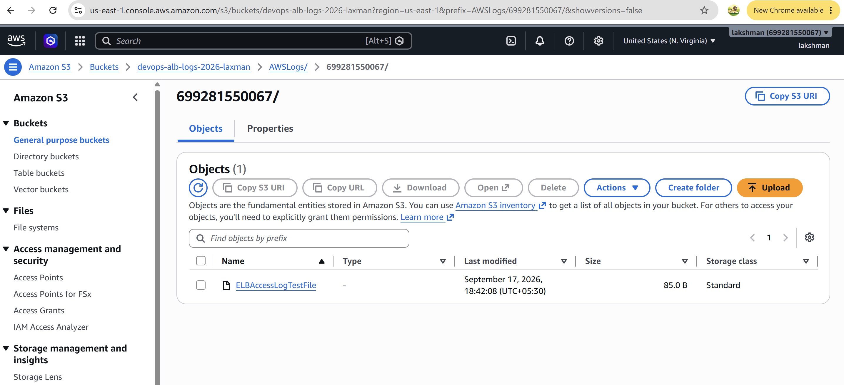

19. Create a CloudWatch Log Group for VPC Flow Logs
CloudWatch → Logs → Log groups → Create log group.
Name: /VPC/DevOps-VPC-FlowLogs
Create the log group. 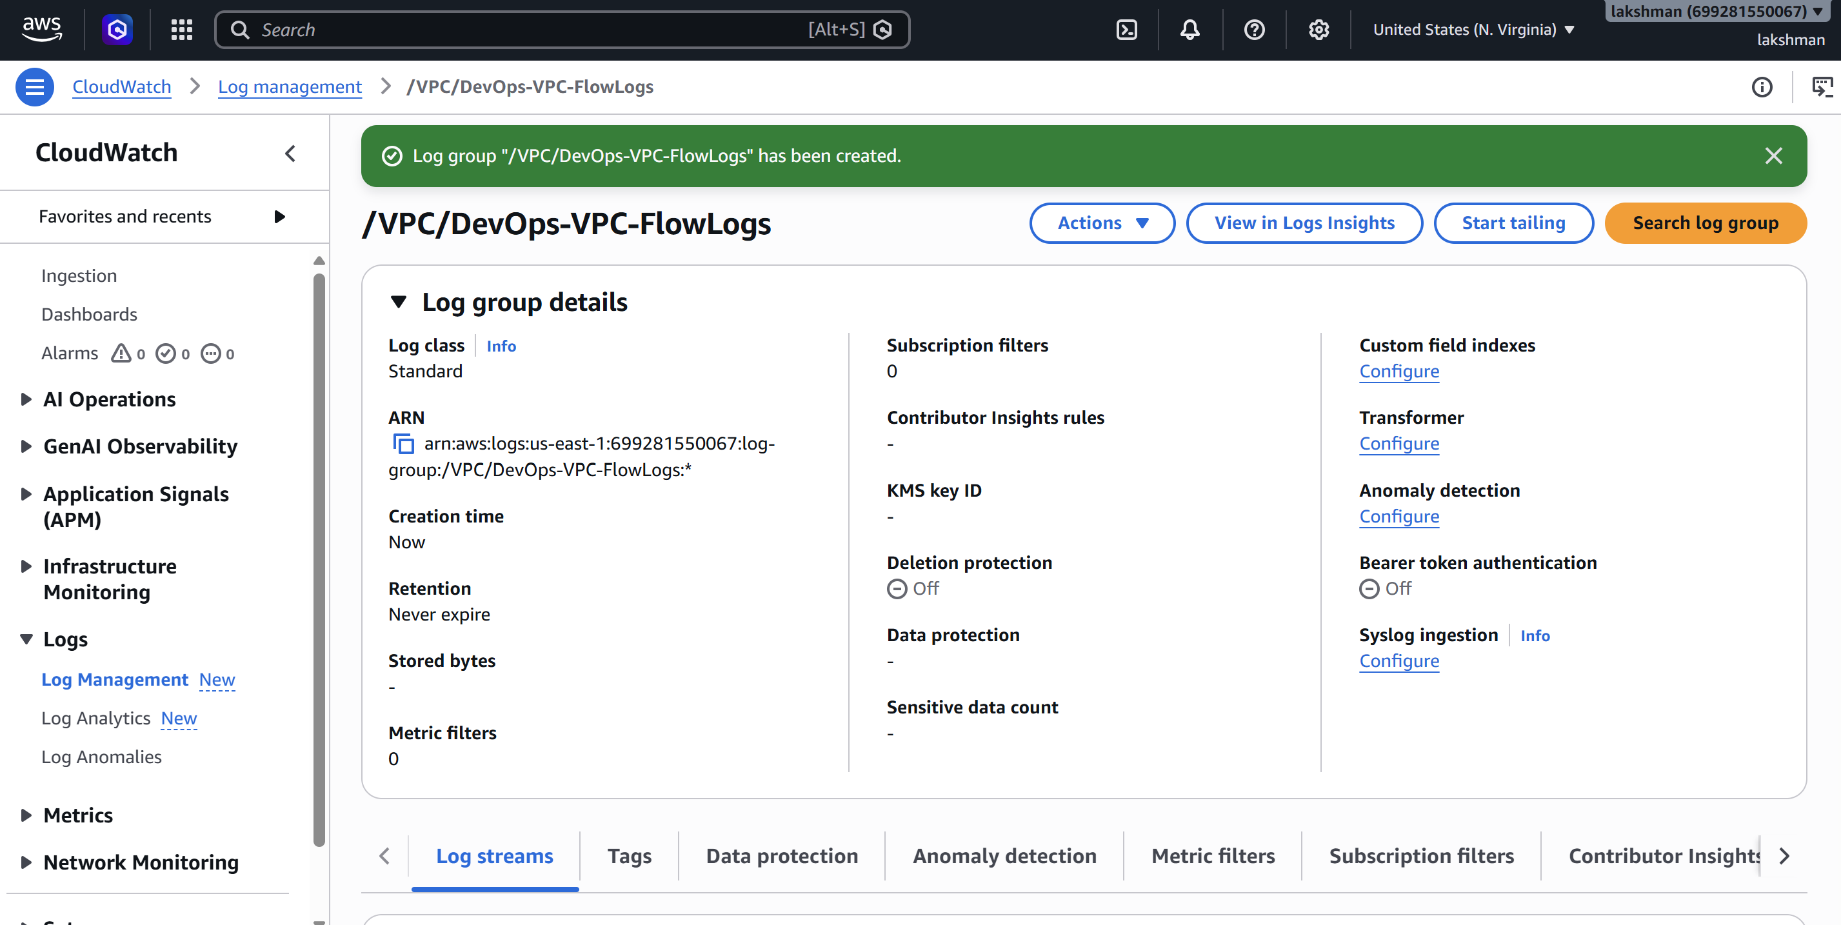

20. Create/Select an IAM Role for VPC Flow Logs
IAM → Roles → Create role. Select the VPC Flow Logs service/use case when offered. The role must allow VPC Flow Logs to publish log events to the selected CloudWatch log group. Use the permissions AWS provides/recommends in the console rather than copying an outdated policy.

21. Enable VPC Flow Logs to CloudWatch
VPC → Your VPCs → select DevOps-VPC → Flow logs → Create flow log.
- Name: DevOps-VPC-FlowLogs
- Filter: All
- Maximum aggregation interval: 1 minute
- Destination: Send to CloudWatch Logs
- Destination log group: /VPC/DevOps-VPC-FlowLogs
- IAM role: VPCFlowLogsRole
Create the flow log. Generate network traffic and verify log streams in CloudWatch. 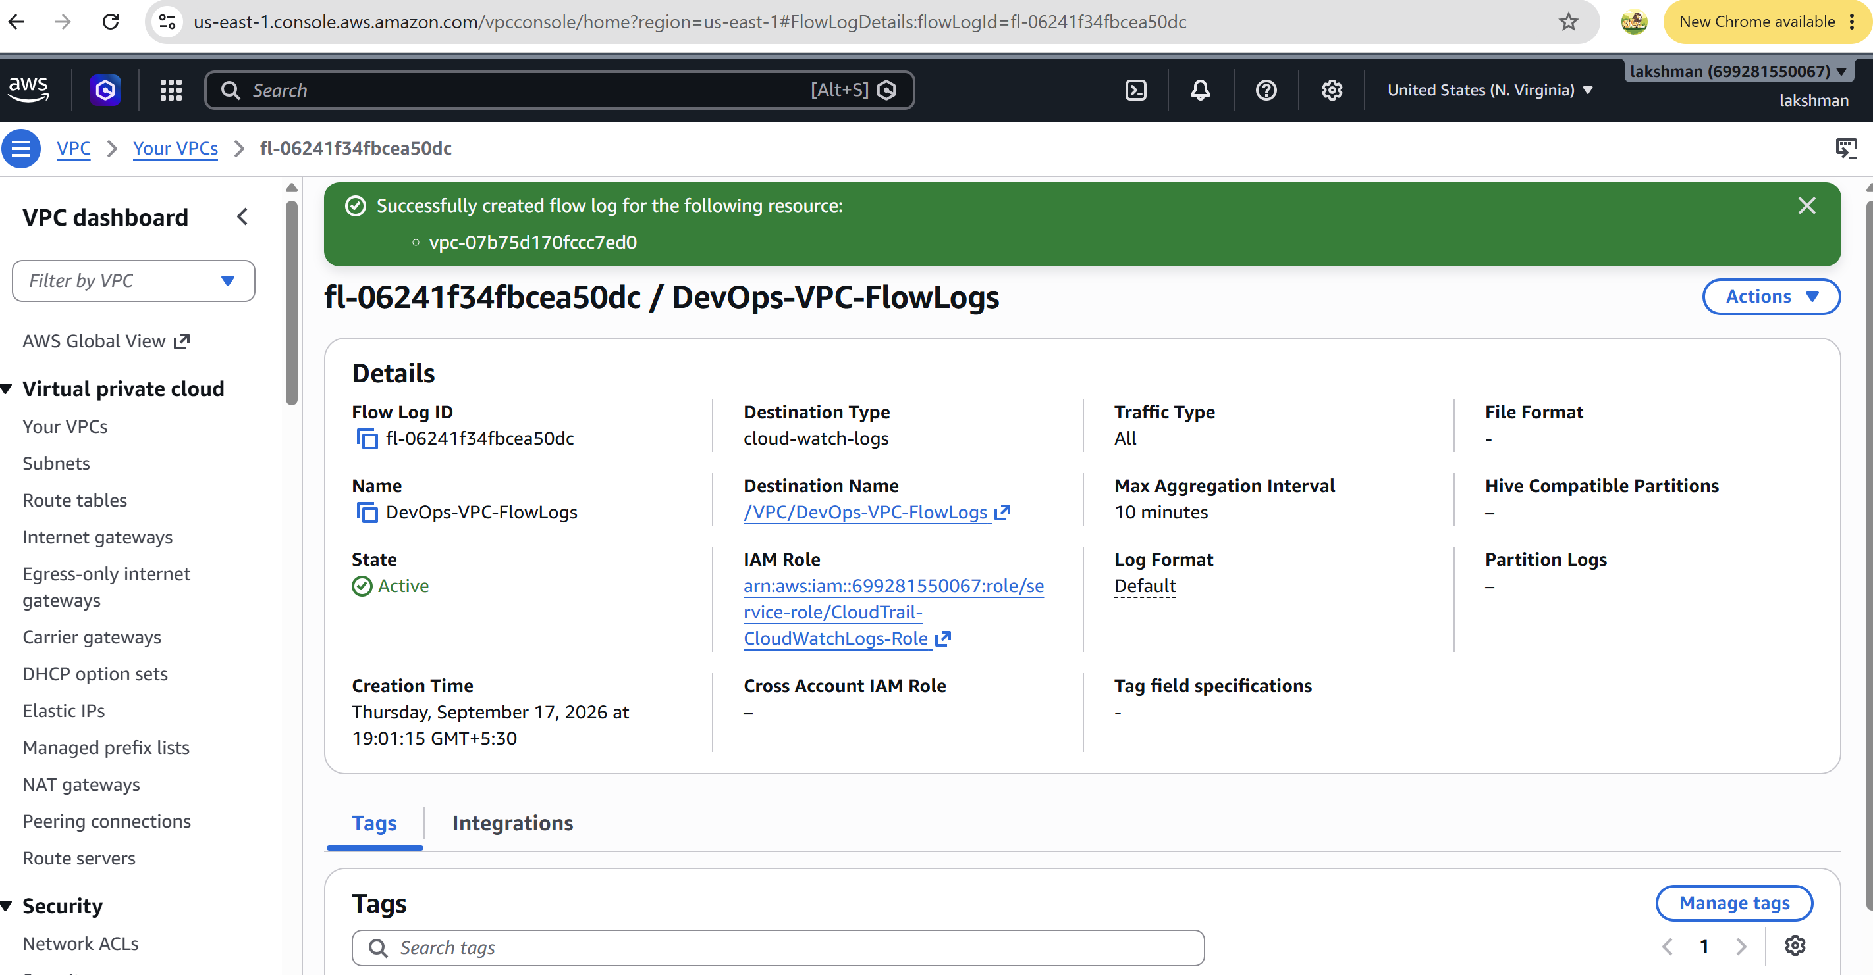

22. Create a CloudWatch Monitoring Dashboard
CloudWatch → Dashboards → Create dashboard.
Name: DevOps-Monitoring-Dashboard.
Add a Line widget → Metrics → EC2 → Per-Instance Metrics → CPUUtilization. Select the Apache EC2 instances. Use Average and a 5-minute period.
Recommended additional ALB widgets: ApplicationELB → Target Group metrics → HealthyHostCount and UnHealthyHostCount. 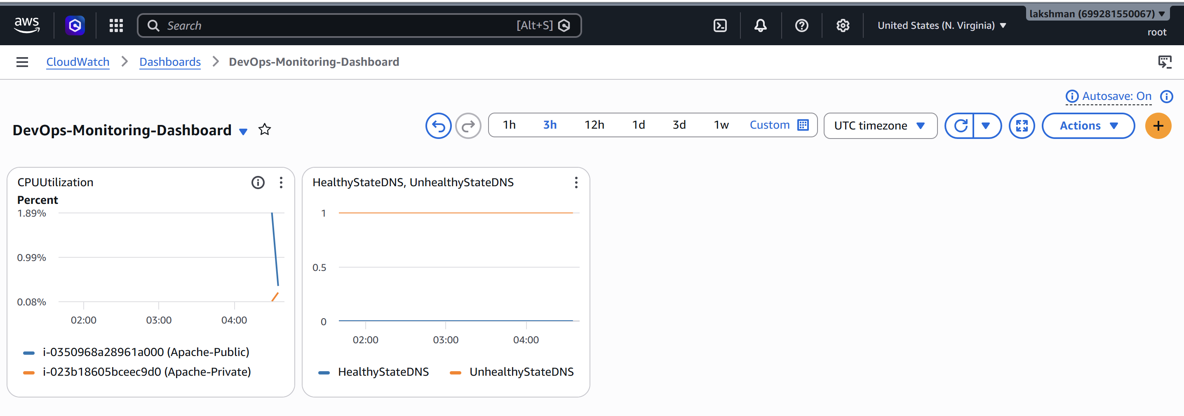

23. Monitor the Apache Service
For service-level monitoring, install and configure the Amazon CloudWatch Agent on the EC2 instances and use the procstat capability to monitor the httpd process. A useful signal is the process count for httpd. A count of 1 or more indicates that the process exists; 0 indicates that it is not running.
Also monitor ALB HealthyHostCount/UnHealthyHostCount. This gives an application-level view of whether Apache targets are responding to the ALB health check.
Optional alarm: httpd process count < 1 → CloudWatch alarm → SNS notification or operational action. 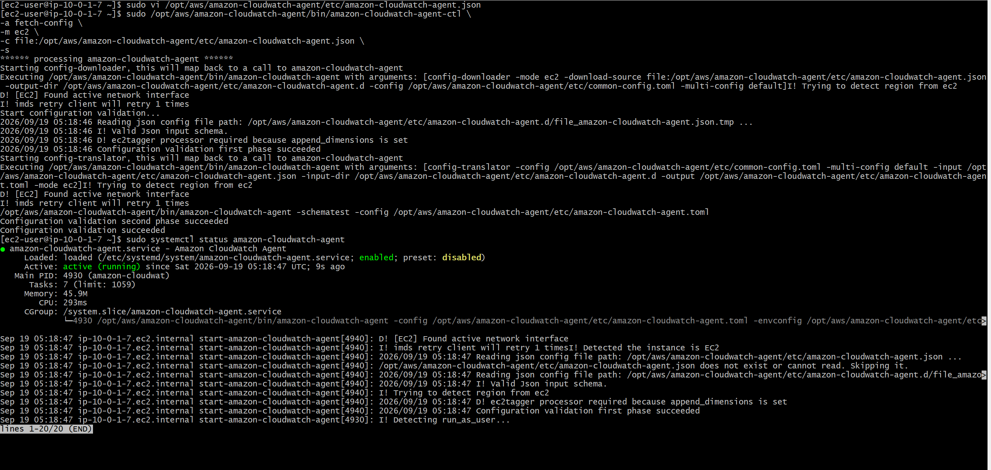

24. Create a Launch Template for Auto Scaling
EC2 → Launch Templates → Create launch template.
- Name: Apache-Launch-Template
- AMI: Amazon Linux 2023
- Instance type: t3.micro (lab example)
- Key pair: your key pair
- Security group: EC2-SG
- Use private subnet(s) for the scalable application tier
- Do not assign public IPs to Auto Scaling application instances
User data:
#!/bin/bash
dnf update -y
dnf install -y httpd
systemctl enable --now httpd
cat > /var/www/html/index.html <<'EOF'
<!DOCTYPE html>
<html>
<head><title>Auto Scaling Apache</title></head>
<body>
<h1>Hello from Auto Scaling Apache EC2</h1>
<p>New instance launched automatically.</p>
</body>
</html>
EOF
Create the launch template. 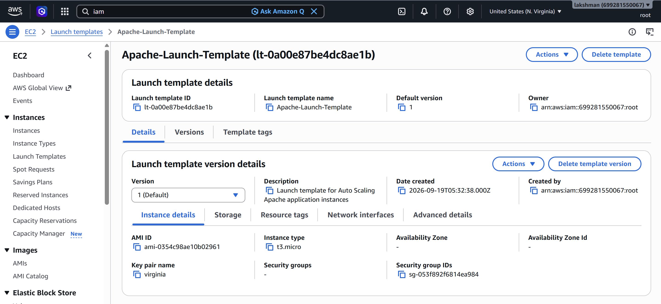

25. Create the Auto Scaling Group
EC2 → Auto Scaling Groups → Create Auto Scaling group.
- Name: Apache-ASG
- Launch template: Apache-Launch-Template
- VPC: DevOps-VPC
- Select private subnet(s)
- Desired capacity: 1
- Minimum capacity: 1
- Maximum capacity: 3
- Health checks: EC2 + ELB when available
Attach the Auto Scaling Group to Apache-TG so new instances are automatically registered with the ALB.
For a production design, create a second private subnet in a second AZ and select both private subnets for the ASG. 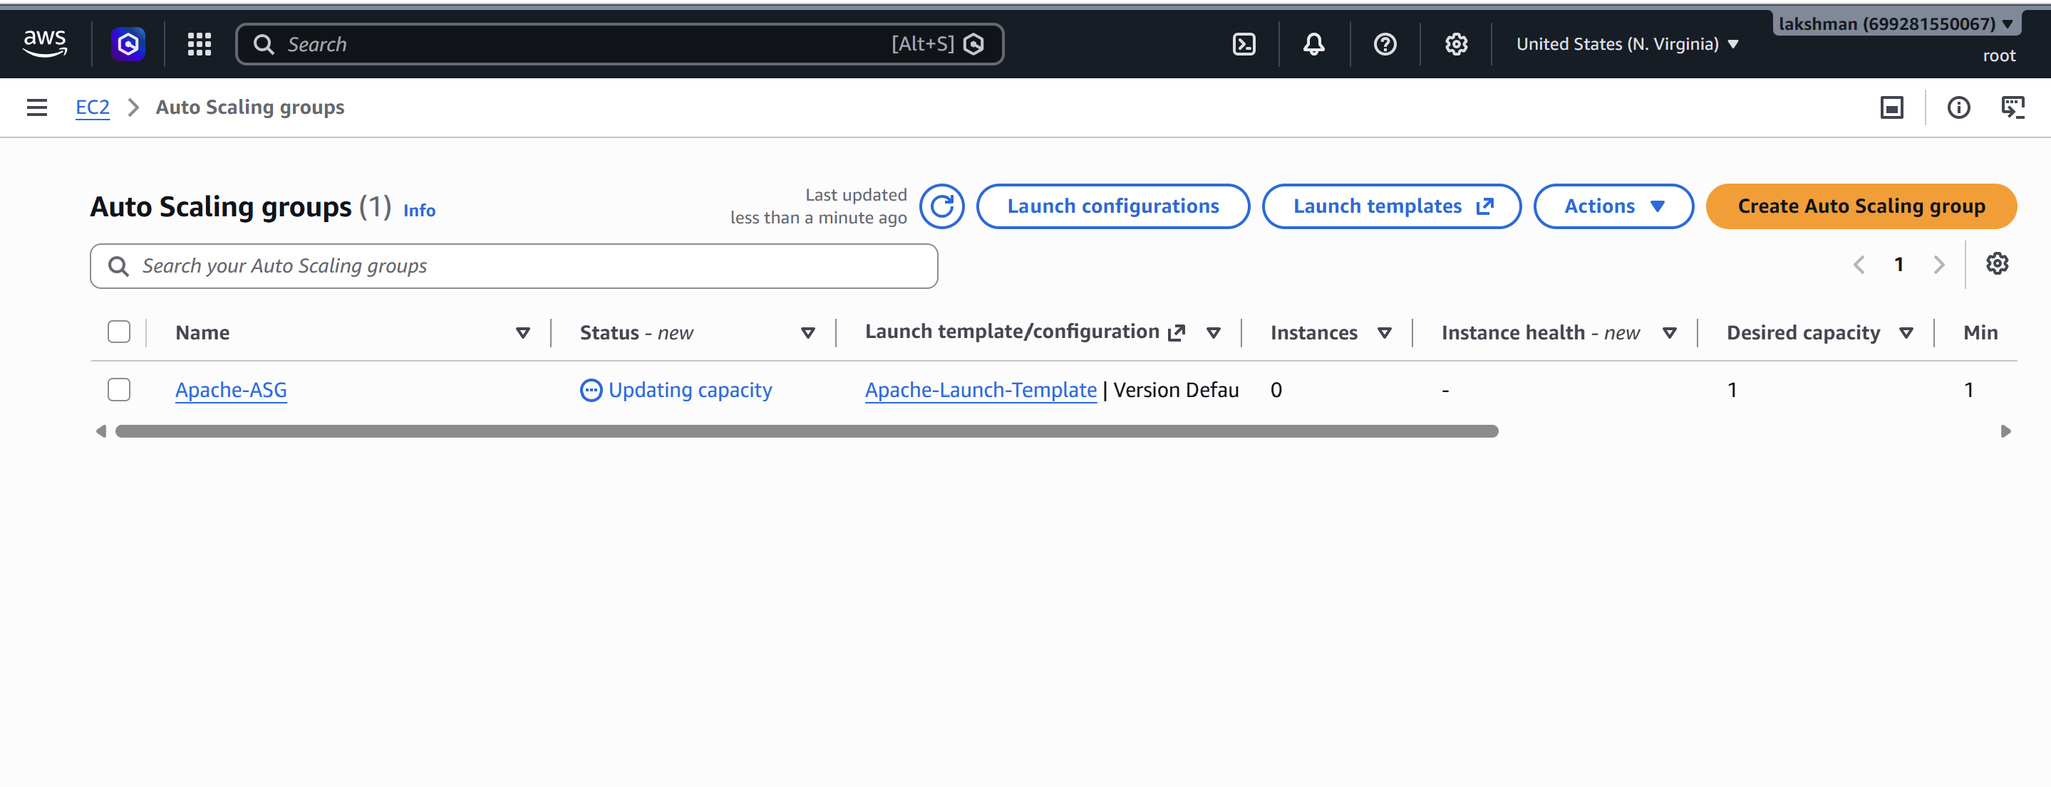

26. Configure CPU Auto Scaling Above 70%
Use an Auto Scaling policy based on CPU. The simplest approach is Target Tracking with a target average CPU utilization of 70%. If the exercise specifically requires an alarm when CPU exceeds 70%, use a CloudWatch alarm and a step/simple scaling policy.
CloudWatch alarm example:
- Metric: EC2 → Auto Scaling Group → CPUUtilization
- Statistic: Average
- Period: 5 minutes
- Condition: Greater than 70%
- Evaluation: e.g. 2 consecutive periods
- Alarm name: Apache-CPU-High
ASG scaling action: add 1 instance. Set maximum capacity to 3 for the lab.
Expected flow: CPU > 70% → CloudWatch Alarm → ASG scaling policy → new EC2 → User Data installs Apache → instance passes ALB health check → instance is added to ALB traffic.
